**SQL+TABLEAU PROJECT**

**END TO END SAELSINSIGHT PROJECT**

# Sales Insights - Data Analysis using Tableau & SQL

**About Project :**

* Performed India based hardware company sales insights - A Data Analysis project.
* Developed ETL mappings using SQL to extract the data from unstructured data and transformed it to the staging area to conduct data cleaning and design star schema data model on Tableau.
* Developed a Tableau dashboard to perform analysis, producing quantitative visualizations in Tableau to draw valuable insights based on different parameters affecting the company performance year on year and further provide business solutions. 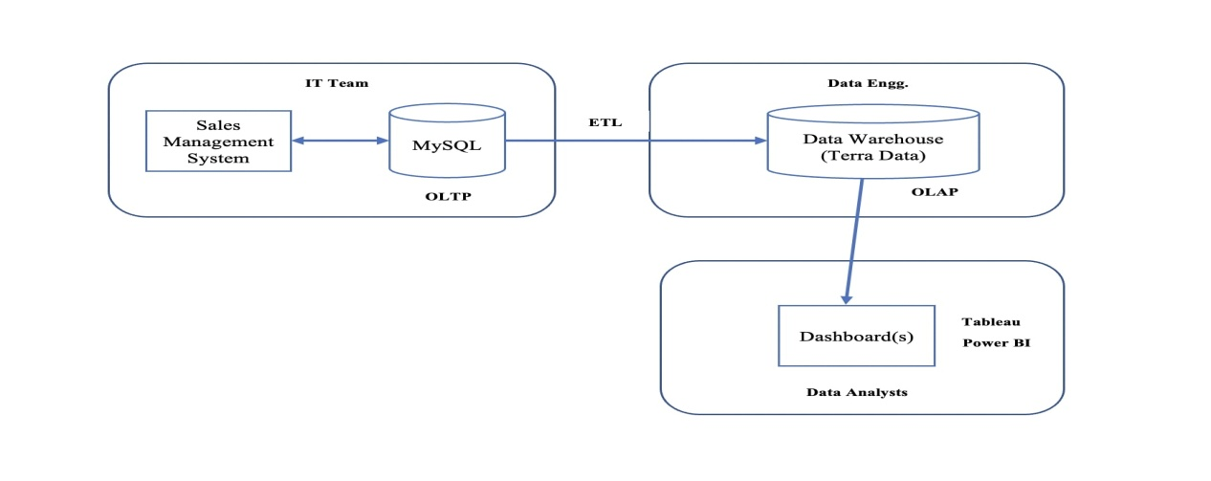

**Problem Statements**

Sales director wants to know the performance of the company in various Indian states & accordingly provide some discount.

* Q1. Revenue breakdown by cities.
* Q2. Revenue brekdown by years & months.
* Q3. Top 5 customers by revenue & sales quantity.
* Q4. Top 5 Products by revenue.
* Q5. Net Profit & Profit Margin by Market

### Approach - Project Planning

#### 1. Purpose: What? Why? What do we want to achieve?

To unlock sales insights that are not visible before for sales team for decision support & automate them to reduced manual time spent in data gathering.

#### 2. Stake Holders: Who will be involved?

* Sales Director,
* I.T. Team,
* Customer Service Team,
* Data & Analytics Team.

#### 3. End Result: What do we want to achieve?

An automated dashboard providing quick & latest sales insights in order to support data driven decision making.

#### 4. Success Criteria: What will be our success criteria?

* Dashboards uncovering sales order insights with latest data available.
* Sales team able to take better decision & prove 10% cost savings of total spend.
* Sales analysts stop data gathering manually in order to save 20% of their business time & reinvest it in value added activity.

### Data Analysis -

**Simple steps you followed to import your sales data into MySQL Workbench**:

1. Open MySQL Workbench.

2.\*Connect to MySQL Server

3. Go to Server > Data Import

4. Select Source Choose "Data Import" from the Server menu.

5\*Choose File: Select your sales data file.

6. . Start Import: Initiate the import process.

7.Monitor Progres: Watch as MySQL Workbench imports your data.

9. Verify Import: Check that the data is correctly imported into your MySQL database.

### Data Analysis Using SQL

1. Show all customer records

SELECT \* FROM customers;

1. Show total number of customers

SELECT count(\*) FROM customers;

1. Show transactions for Chennai market (market code for chennai is Mark001

SELECT \* FROM transactions where market\_code='Mark001';

1. Show distrinct product codes that were sold in chennai

SELECT distinct product\_code FROM transactions where market\_code='Mark001';

1. Show transactions where currency is US dollars

SELECT \* from transactions where currency="USD"

1. Show transactions in 2020 join by date table

SELECT transactions.\*, date.\* FROM transactions INNER JOIN date ON transactions.order\_date=date.date where date.year=2020;

1. Show total revenue in year 2020,

SELECT SUM(transactions.sales\_amount) FROM transactions INNER JOIN date ON transactions.order\_date=date.date where date.year=2020 and transactions.currency="INR\r" or transactions.currency="USD\r";

1. Show total revenue in year 2020, January Month,

SELECT SUM(transactions.sales\_amount) FROM transactions INNER JOIN date ON transactions.order\_date=date.date where date.year=2020 and and date.month\_name="January" and (transactions.currency="INR\r" or transactions.currency="USD\r");

1. Show total revenue in year 2020 in Chennai

SELECT SUM(transactions.sales\_amount) FROM transactions INNER JOIN date ON transactions.order\_date=date.date where date.year=2020 and transactions.market\_code="Mark001";

### Tableau Public Dashboards:

### Connections:

### F:\cds syudy\PROJECT datamites\My tableau project\5Tableau_SQL sales important ATLIQ\EXTRACTING excelshhetsin tableau.PNG

**Data Cleaning in Tableau :**

**Dashboard in Tableau :**

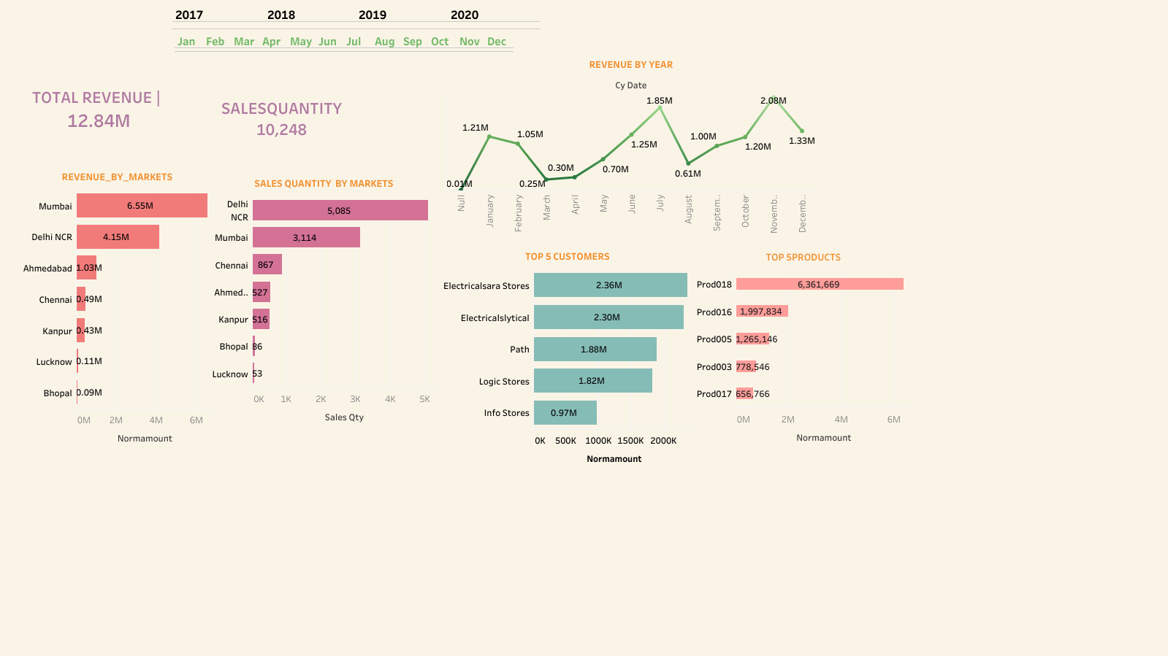

**DETAILS ABOUT PROJECT STEPS :**

**\*\*Sales Dashboard Project Overview:\*\***

This project aims to develop an end-to-end sales dashboard using SQL for data extraction and Tableau for data visualization and analysis. The dashboard will provide insights into sales performance, trends, and key metrics to support decision-making for a hardware company based in India.

**Project Steps:**

1. Data Extraction from SQL:

- Connect to the SQL database using tools like MySQL Workbench.

- Execute queries to extract data from tables including transactions, customers, markets, dates, and products.

- Export the query results into CSV files for further processing.

2. Data Preparation in Tableau:

- Import the CSV files into Tableau for data cleaning and preparation.

- Combine tables by creating relationships between them based on common fields.

- Perform data cleaning tasks such as handling missing values, removing duplicates, and standardizing data formats.

3. Data Analysis and Visualization:

- Create calculated fields in Tableau to derive new metrics such as total revenue, total quantity sold, etc.

- Develop visualizations to analyze sales trends, top-performing products, top customers, and geographical sales distribution.

- Utilize filters to enable dynamic exploration of data by year, month, product category, etc.

4. Dashboard Creation:

- Design a dashboard layout that provides an intuitive and interactive user experience.

- Incorporate visualizations and key metrics such as total revenue, total quantity sold, top 5 products, top 5 customers, etc.

- Implement dynamic filters to allow users to adjust the view based on their preferences.

- Include trend analysis charts to identify patterns and outliers over time.

5. Insights and Conclusion:

- Analyze the dashboard to derive actionable insights and trends in sales performance.

- Highlight significant findings such as seasonal sales trends, top-selling products, customer preferences, etc.

- Summarize conclusions drawn from the analysis and recommend strategic actions based on the insights gained.

Conclusion:

By leveraging SQL for data extraction and Tableau for visualization and analysis, this sales dashboard project provides a comprehensive solution for gaining actionable insights into sales performance. The interactive dashboard enables stakeholders to make informed decisions and drive business growth effectively.